Full Stack Development with MERN

Project Documentation Format

Project Title: ServiceNow-Based Employee Laptop Request Application
Platform Note: The supplied FSD template is written for a MERN application. This project is implemented on ServiceNow, so the same documentation sections are mapped to ServiceNow equivalents rather than inventing React/Node/MongoDB components.

Introduction
Project Title: ServiceNow-Based Employee Laptop Request Application
Team Members: Team member names and individual roles were not provided in the source project material. The project records show the work assigned to Gurram Prasanna Sai.

Project Overview
The project implements a centralized and controlled process for managing employee laptop requests in an IT organization. It replaces manual email and verbal requests with a standardized digital workflow.
  - Employees submit a Laptop Request through a ServiceNow Record Producer.
  - Requests distinguish Basic and Advance laptop usage.
  - A Business Rule prevents duplicate laptop requests within the same calendar year.
  - Flow Designer starts manager approval automatically and updates the request status.
  - Approval/rejection notifications keep the requester informed.
  - Roles, groups and ACLs control employee and manager access.

Architecture
Frontend: Service Portal / Service Catalog Record Producer provides the employee-facing request form.
Backend: ServiceNow Business Rules provide validation and policy enforcement, while Flow Designer provides the approval workflow and notifications.
Database: A custom Laptop Request Form table stores request data, with reference fields linked to the User table. The approval relationship connects requests with sysapproval_approver.

Setup Instructions
Prerequisites: A ServiceNow development instance with suitable application-development permissions. The project screenshots also show use of an elevated role when creating ACLs.
Implementation sequence:
  - Create/select an Update Set and make it current.
  - Create the custom application and define its scope/access settings.
  - Create the Laptop Request Form table and configure its fields.
  - Create the Employee Service Catalog entry and Laptop Request Record Producer.
  - Configure the approval relationship with sysapproval_approver.
  - Create the Business Rule for yearly duplicate-request prevention.
  - Create IT Manager and IT Employee roles and groups.
  - Configure table-level ACLs for read/create/write access.
  - Build the Flow Designer approval workflow and email notifications.
  - Test the request lifecycle and commit/export the Update Set for deployment.

Folder Structure
The supplied template expects Client and Server folders. This ServiceNow project does not use a local MERN client/server folder structure. Its logical structure is organized by ServiceNow application artifacts:
  - Application: Project Application
  - Data: Laptop Request Form table and configured fields
  - Catalog: Employee Service Catalog and Laptop Request Record Producer
  - Logic: Business Rules
  - Workflow: Flow Designer approval flow
  - Security: Roles, Groups and ACLs
  - Deployment: Update Set

Running the Application
The project is executed inside the configured ServiceNow instance rather than with local npm start commands. Employees access the Laptop Request entry through the Service Catalog/Service Portal.
Typical request lifecycle: Record Created → Pending Approval → Manager Approval → Approved/Rejected
→ Notification.

API Documentation
No custom REST API endpoints are documented in the supplied project material. The implementation relies on native ServiceNow platform operations, table records, Record Producer mapping, Business Rules and Flow Designer.

Authentication
Authentication is handled by the ServiceNow platform. Authorization is implemented through the project-defined roles, groups and ACLs.

Role | Purpose / Access
it_employee | Create and manage laptop requests; read request status.
it_manager | Read-only access to laptop request records for review/approval.

User Interface
The project uses a ServiceNow Service Portal/Service Catalog interface. The Record Producer provides the employee-facing Laptop Request form.
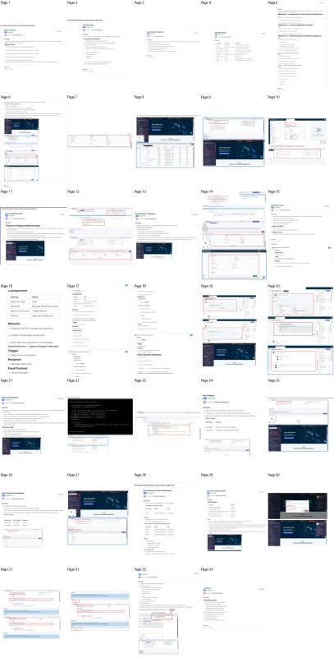
Figure 2. Project implementation screenshots; the source project PDF contains the detailed configuration screens.

Testing
Testing covered request creation, field/choice validation, duplicate-request prevention, role-based access and the approval workflow. The project records specifically validate that an employee can create/edit a request, a second request in the same year is blocked, and managers can view but not create/modify requests.

Scenario | Expected Result
Employee creates request | Allowed
Employee edits request | Allowed
Employee submits second request in same year | Blocked
Manager views request list | Allowed
Manager tries to edit/create | Blocked

Screenshots or Demo
The supplied project PDF contains configuration and validation screenshots across the implementation, including Record Producer, Flow Designer, Business Rule, roles/groups, ACLs and update-set deployment.

Known Issues
  - No custom API or external integration is documented in the supplied material.
  - Actual production deployment details are not specified; the project documents focus on development-instance configuration and Update Set deployment.
  - The source template asks for a MERN folder structure, but the actual solution is ServiceNow-based.

Future Enhancements
  - Extend approval workflows and notifications.
  - Add reporting and dashboards for IT and management.
  - Integrate laptop provisioning and asset-management activities after approval.
  - Add richer request tracking and operational metrics.
  - Introduce additional automation around fulfillment.

